1. Launch one EC2 using Amazon Linux 2 image and add a script in user data to
install Apache.
Objective
To launch an Amazon Linux 2 EC2 instance and install Apache using User Data.
Steps
1. Open AWS Console → EC2 → Launch Instance.
2. Select the Amazon Linux 2 AMI.
3. Select the required instance type.
4. Select/create a Key Pair.
5. Configure the Security Group:
a. Allow SSH – Port 22
b. Allow HTTP – Port 80
6. Go to Advanced Details → User Data.
7. Enter the following script:
#!/bin/bash
yum update -y
yum install -y httpd
systemctl enable httpd
systemctl start httpd
echo "<h1>Apache Server - Amazon Linux 2</h1>" > /var/www/html/index.html
8. Click Launch Instance.
9. Wait until the instance status shows Running.
10. Copy the Public IPv4 address
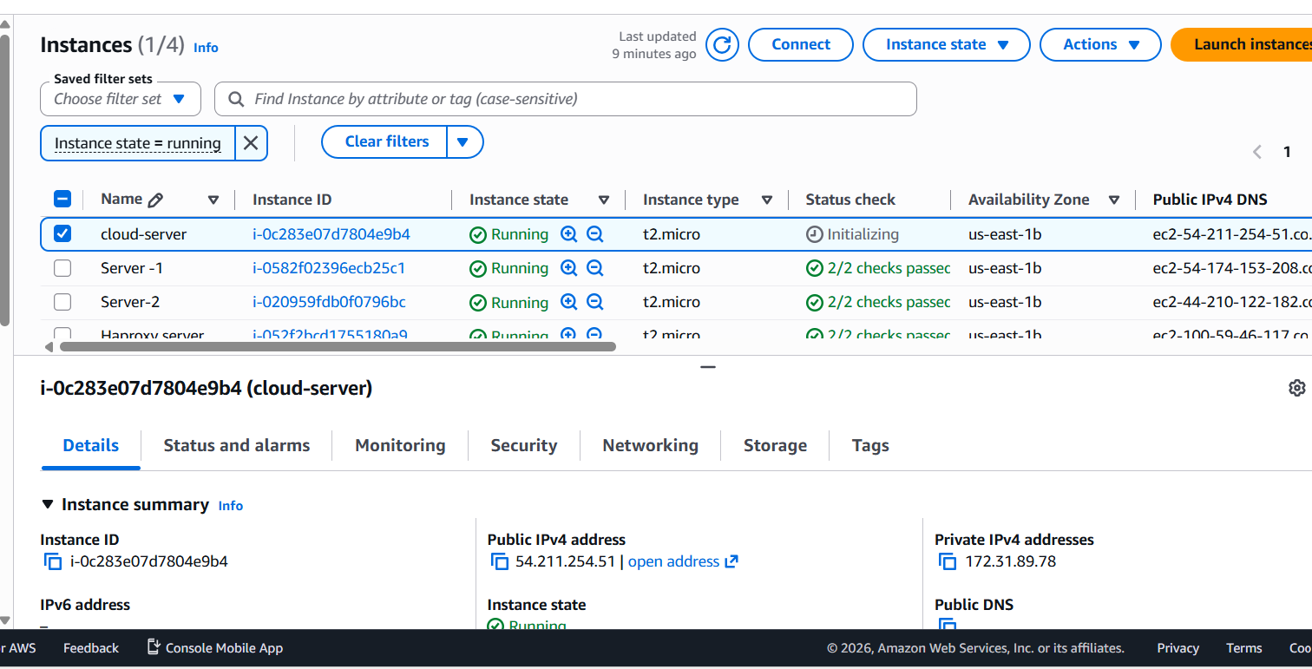
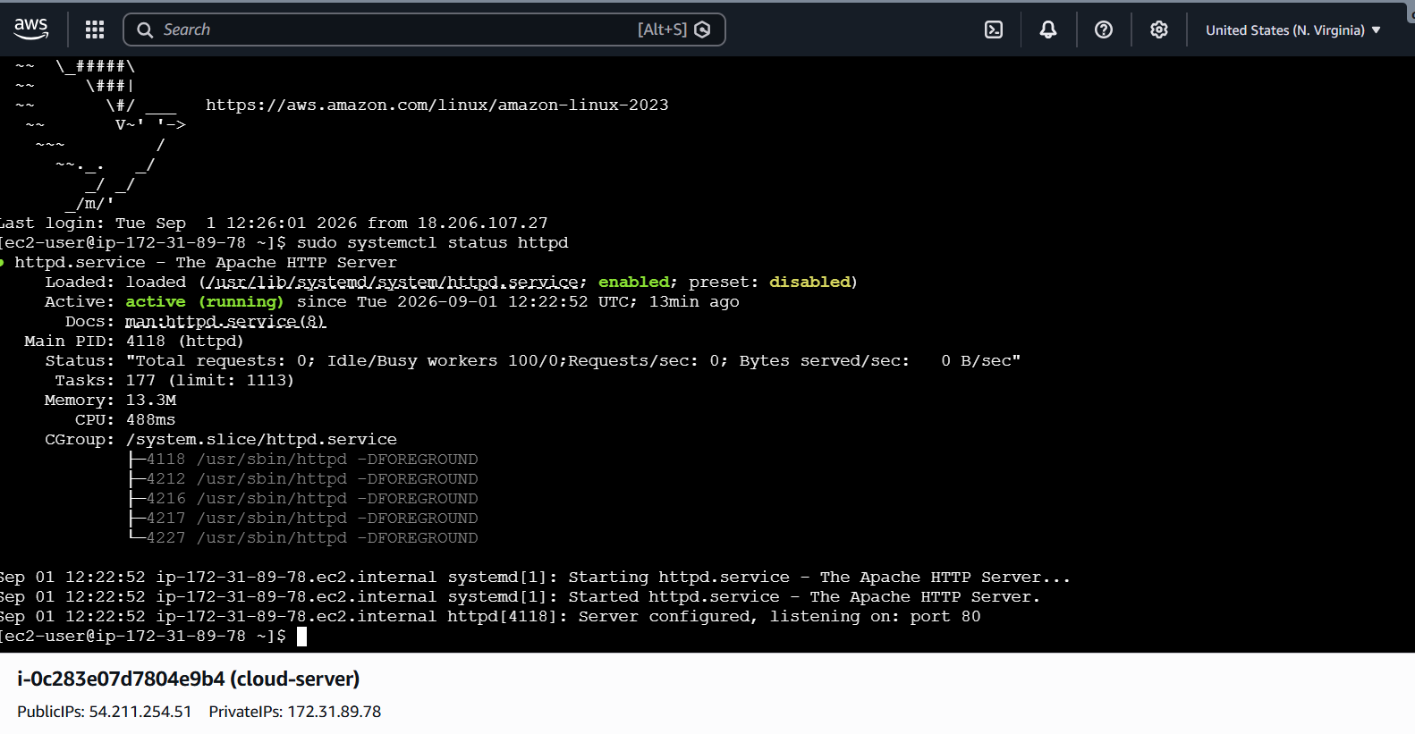

2.Launch one EC2 using Ubuntu image and add a script in user data to install Nginx.
Objective
To launch an Ubuntu EC2 instance and install Nginx automatically using User Data.
Steps
1. Open AWS Console → EC2 → Launch Instance.
2. Enter the instance name as Ubuntu-Nginx.
3. Select Ubuntu Server 24.04 LTS as the AMI.
4. Select the required instance type.
5. Select the Key Pair.
6. Configure the Security Group:
a. Allow SSH – Port 22 – My IP
b. Allow HTTP – Port 80 – Anywhere
7. Enable Auto-assign Public IP.
8. Go to Advanced Details → User Data.
9. Enter the following script:
#!/bin/bash
apt-get update -y
apt-get install -y nginx
systemctl enable nginx
systemctl start nginx
echo "<h1>Nginx Server - Ubuntu</h1>" > /var/www/html/index.html
10. Click Launch Instance.
11. Wait until the instance status shows Running.
12. Copy the Public IPv4 address.
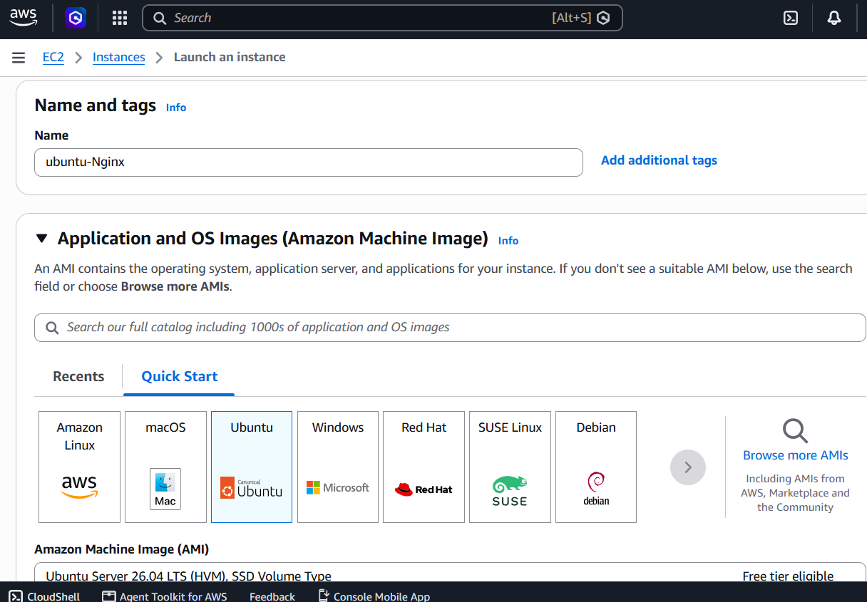
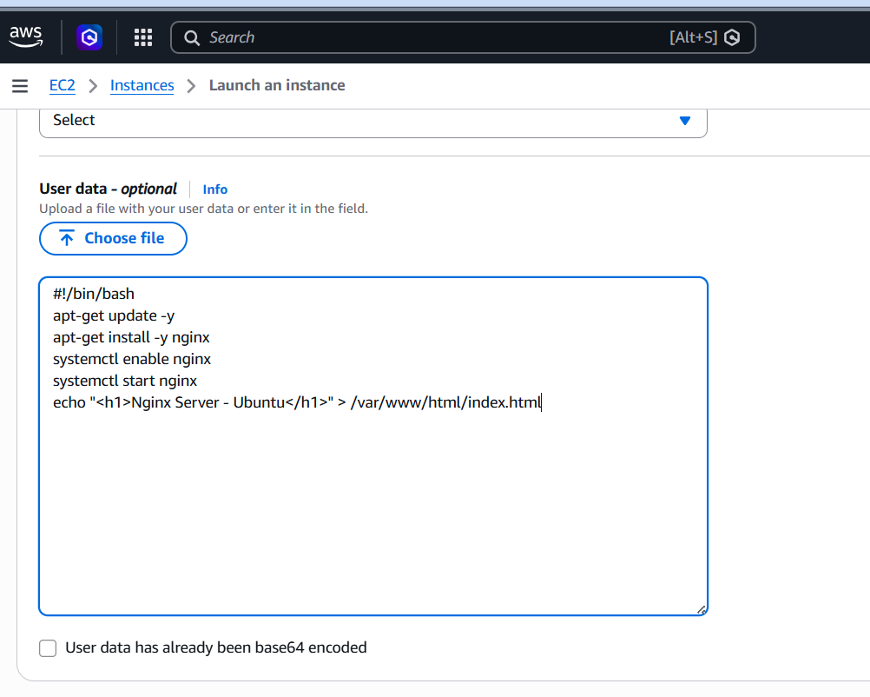
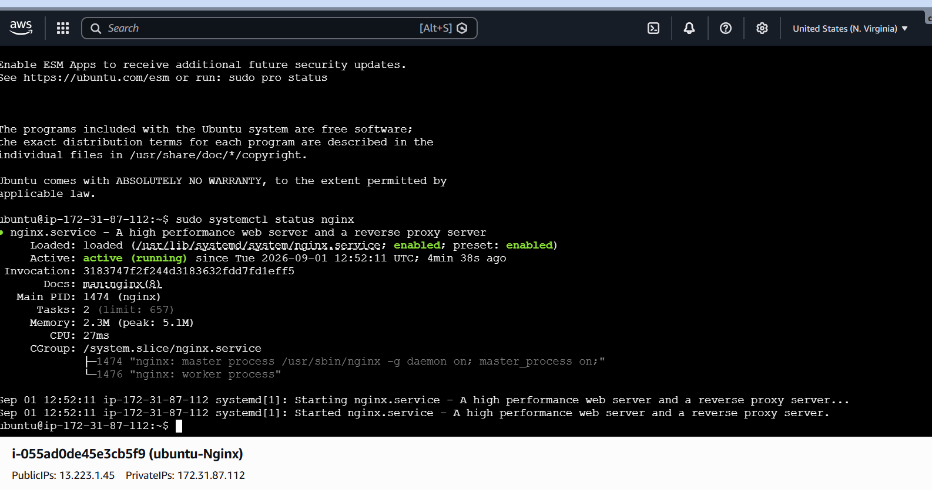
Result
Task 2 completed successfully. Nginx was installed automatically on the Ubuntu EC2 instance
using User Data.

3.Launch one Windows server and install Tomcat on Windows.
Objective
To launch a Windows Server EC2 instance in AWS, connect to it using RDP, install Java JDK
17, install Apache Tomcat 10.1.59, configure the required environment variables, and verify that
Tomcat is running successfully.
2. Steps / Implementation
Step 1: Launch Windows EC2 Instance
1. Log in to the AWS Management Console.
2. Open EC2.
3. Click Launch Instance.
4. Enter the instance name:
Windows-Tomcat
5. Select a Windows Server AMI.
6. Select the required instance type.
7. Select the key pair.
8. Configure the Security Group.
9. Allow RDP – TCP 3389 from your IP address.
10. Launch the instance.
11. Wait until the instance status shows Running.
Step 2: Connect to Windows EC2 Using RDP
1. Select the Windows EC2 instance.
2. Click Connect.
3. Select RDP client.
4. Click Get password.
5. Upload the .pem key file.
6. Decrypt and copy the Administrator password.
7. Download the Remote Desktop file.
8. Open the .rdp file.
9. Log in using:
Username: Administrator
10. Enter the decrypted password.
The Windows Server desktop was opened successfully.
Step 3: Install Java JDK 17
Java was installed on the Windows EC2 server because Tomcat requires Java.
After installation, open Command Prompt and run:
java -version
Expected result:
java version "17..."
Verify the Java location:
where java
The JDK 17 installation was available under:
C:\Program Files\Java\jdk-17
Step 4: Set JAVA_HOME
Set the Java environment variable:
JAVA_HOME=C:\Program Files\Java\jdk-17
Verify it using:
echo %JAVA_HOME%
Expected result:
C:\Program Files\Java\jdk-17
Step 5: Download and Extract Tomcat
1. Download Apache Tomcat 10.1.59 for Windows.
2. Extract the Tomcat ZIP file.
3. Create/use the following directory:
C:\Tomcat
4. Place the Tomcat files inside the Tomcat directory.
The Tomcat installation path used was:
C:\Tomcat\apache-tomcat-10.1.59
The important Tomcat directories were:
C:\Tomcat\apache-tomcat-10.1.59\bin
C:\Tomcat\apache-tomcat-10.1.59\conf
C:\Tomcat\apache-tomcat-10.1.59\logs
C:\Tomcat\apache-tomcat-10.1.59\webapps
Step 6: Configure Tomcat Environment Variables
The Tomcat environment variables were configured as follows:
CATALINA_BASE=C:\Tomcat\apache-tomcat-
10.1.59CATALINA_HOME=C:\Tomcat\apache-tomcat-10.1.59JRE_HOME=C:\Program
Files\Java\jdk-17
The Tomcat temporary directory was:
C:\Tomcat\apache-tomcat-10.1.59\temp
Step 7: Open Tomcat bin Directory
Open Command Prompt and run:
cd C:\Tomcat\apache-tomcat-10.1.59\bin
Check the files:
dir
The startup.bat file should be available in the bin directory.
Step 8: Start Tomcat
Run:
startup.bat
Tomcat starts successfully.
Alternatively:
catalina.bat run
can be used to run Tomcat in the current Command Prompt window.
Step 9: Verify Tomcat
Open a browser on the Windows server and enter:
http://localhost:8080
The Apache Tomcat welcome page should appear.
To check whether port 8080 is listening, run:
netstat -ano | findstr :8080
A listening entry for port 8080 confirms that Tomcat is running.
Step 10: Verify Tomcat from EC2 Public IP
If port 8080 is allowed in the EC2 Security Group, Tomcat can also be accessed from the local
computer using:
http://<EC2-Public-IP>:8080
3. Result
Successfully launched a Windows Server EC2 instance and connected to it using RDP. Java
JDK 17 was installed and configured. Apache Tomcat 10.1.59 was extracted under
C:\Tomcat\apache-tomcat-10.1.59, and the required CATALINA_HOME,
CATALINA_BASE, and JRE_HOME environment variables were configured. Tomcat was
started successfully using startup.bat and verified on port 8080 through the Apache
Tomcat welcome page.

4. Evidence / Screenshots
Add these screenshots to the task completion document:
1. Windows EC2 instance – Running
2. RDP connection to Windows Server
3. Java JDK 17 version
java -version
4. JAVA_HOME verification
echo %JAVA_HOME%
5. Tomcat folder
C:\Tomcat\apache-tomcat-10.1.59
6. Tomcat environment variables
a. CATALINA_HOME
b. CATALINA_BASE
c. JRE_HOME
7. Tomcat bin folder showing startup.bat
8. Tomcat startup
startup.bat
9. Port 8080 verification
netstat -ano | findstr :8080
10. Apache Tomcat welcome page
http://localhost:8080

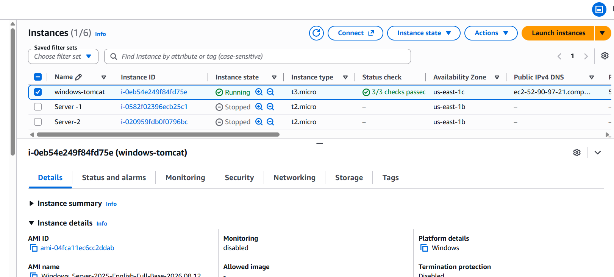
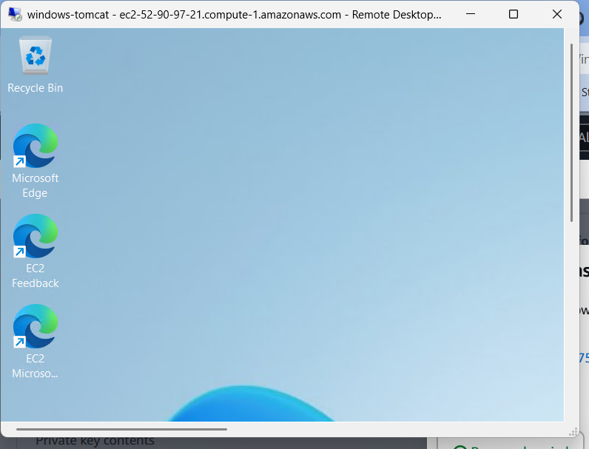
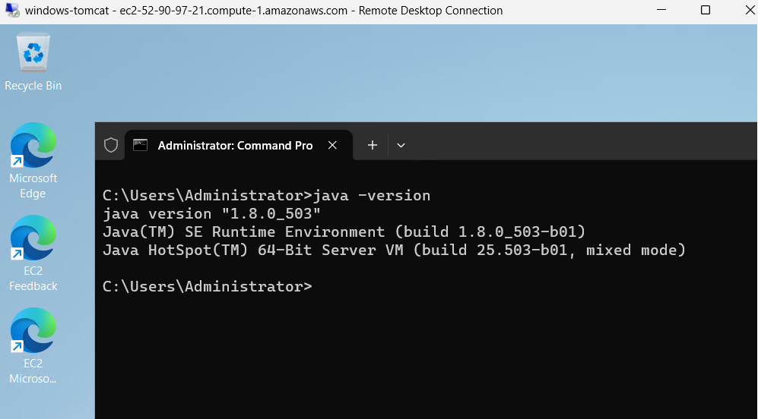
Conclusion
The Windows EC2 server was successfully launched and configured with JDK 17 and Apache
Tomcat 10.1.59. Tomcat was successfully started and verified through port 8080, completing
the Windows server and Tomcat installation task.

4.Take a snapshot of the instance created in Task 1.

Steps
1. Open AWS Management Console → EC2.
2. Go to Instances.
3. Select the Amazon Linux 2 EC2 instance created in Task 1.
4. Open the Storage tab.
5. Under Block devices, click the attached Volume ID.
6. In the Volumes page, select the volume.
7. Click Actions → Create snapshot.
8. Enter the description:Task 1 Amazon Linux 2 Apache Snapshot
9. Click Create snapshot.
10. Go to Elastic Block Store → Snapshots.
11. Select the newly created snapshot.
12. Wait until the Status becomes Completed
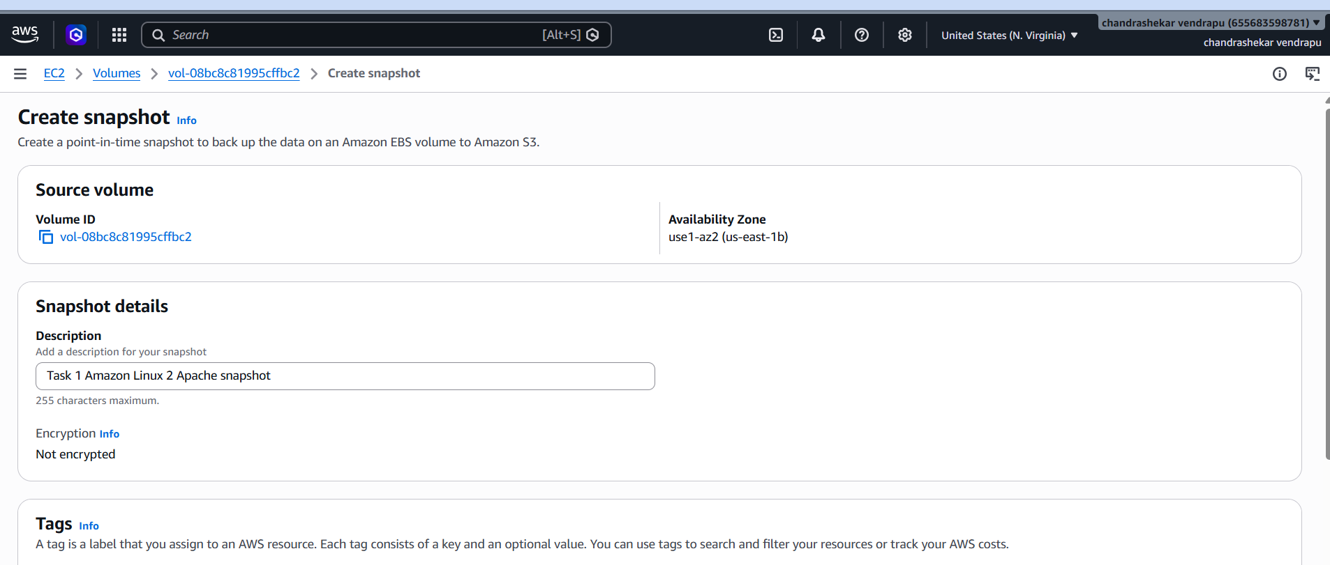
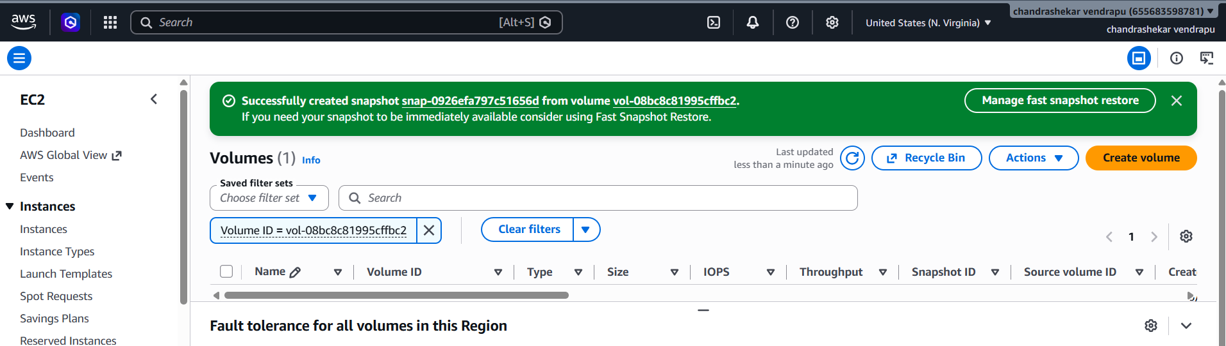
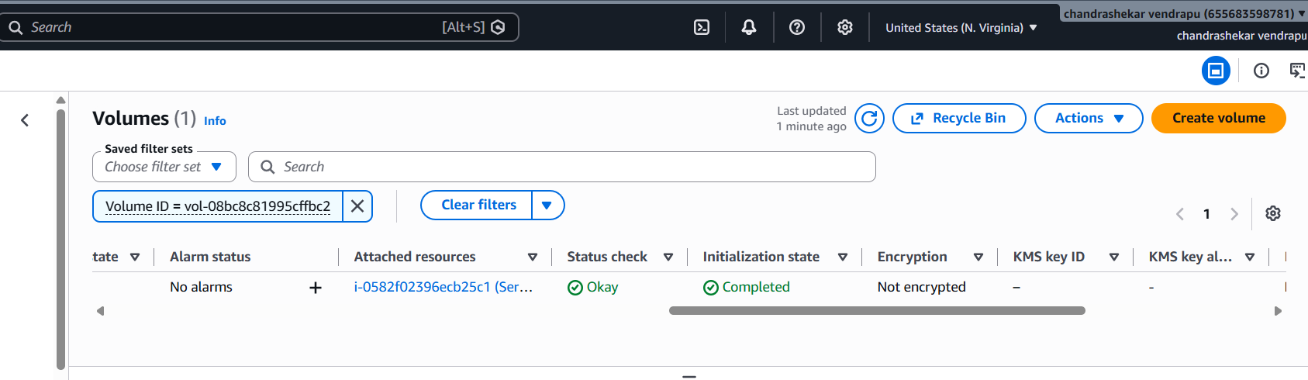

5.Assign passwordless authentication for the EC2 created in Task 2.
Steps
1. Open Git Bash on your local Windows system.
2. Connect to the Ubuntu EC2 instance from Task 2 using the .pem key:ssh -i "your-
key.pem" ubuntu@YOUR_PUBLIC_IP
3. Create the SSH directory:mkdir -p ~/.ssh
4. Set the directory permission:chmod 700 ~/.ssh
5. On your local Git Bash, display your public SSH key:cat ~/.ssh/id_rsa.pub
6. Copy the complete public key.
7. Back inside the Ubuntu EC2, open:nano ~/.ssh/authorized_keys
8. Paste the public key into the file.
9. Save the file:
Ctrl + O → Enter → Ctrl + X
10. Set the required permission:chmod 600 ~/.ssh/authorized_keys
11. Exit the EC2:exit
12. From your local Git Bash, connect again without the .pem file:ssh
ubuntu@YOUR_PUBLIC_IP
13. Verify the login:whoamiExpected output:ubuntu
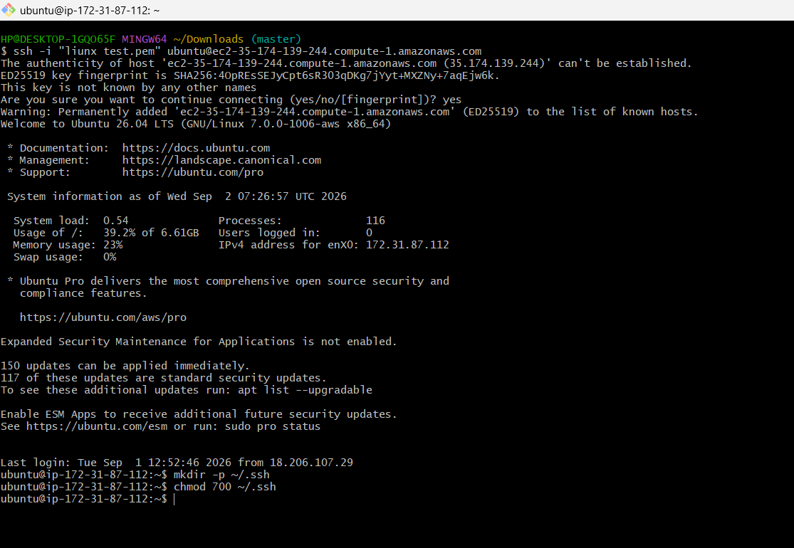
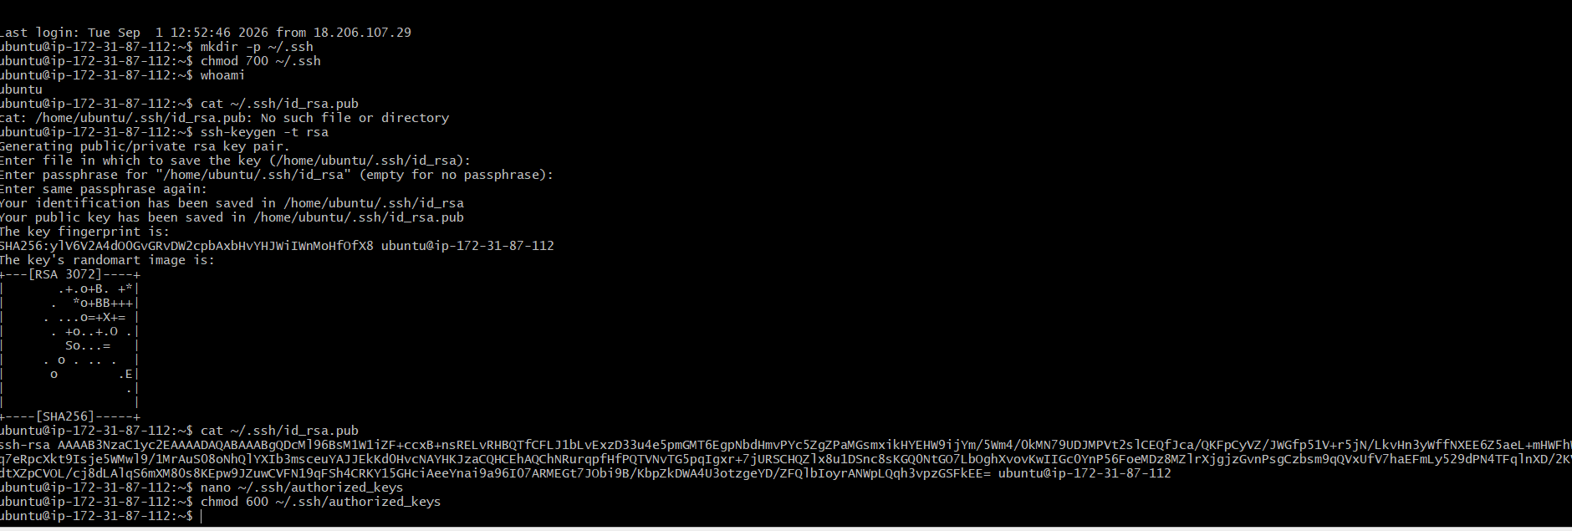
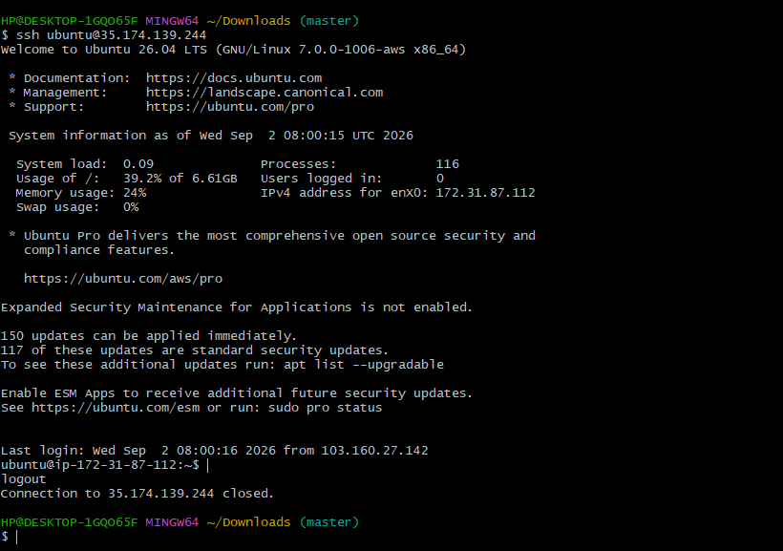

Result
Successfully configured passwordless SSH authentication for the Ubuntu EC2 instance
created in Task 2. The connection was verified without specifying the .pem key file

6.Launch any EC2 using the spot purchasing option.
Steps
1. Open AWS Management Console → EC2.
2. Click Launch instance.
3. Enter an instance name, for example:Spot-Instance
4. Select an available Amazon Linux AMI.
5. Select an instance type, for example:t3.micro
6. Select an existing Key pair.
7. Under Advanced details, find Purchasing option.
8. Select:
Request Spot Instances.
9. Configure the required network and security group settings.
10. Click Launch instance.
11. Go to EC2 → Instances.
12. Select the newly launched instance.
13. Verify that the Lifecycle is shown as:
Spot

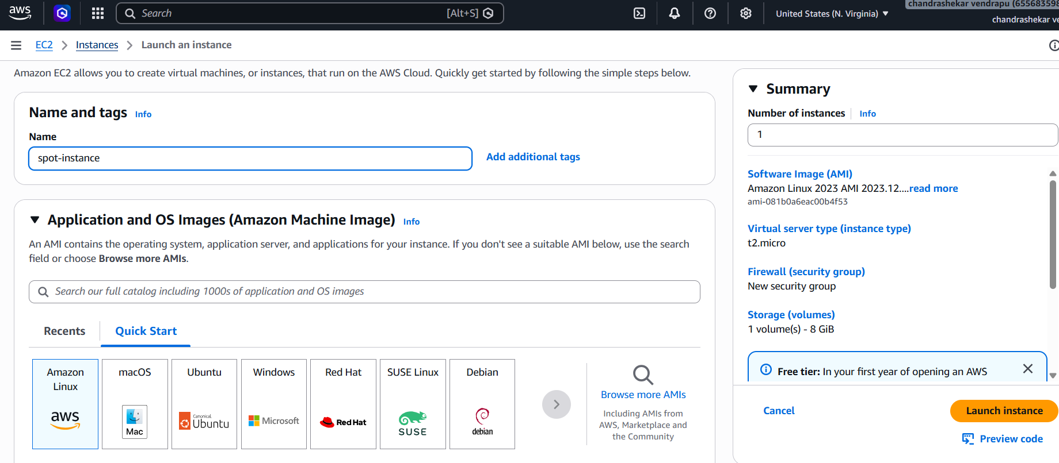
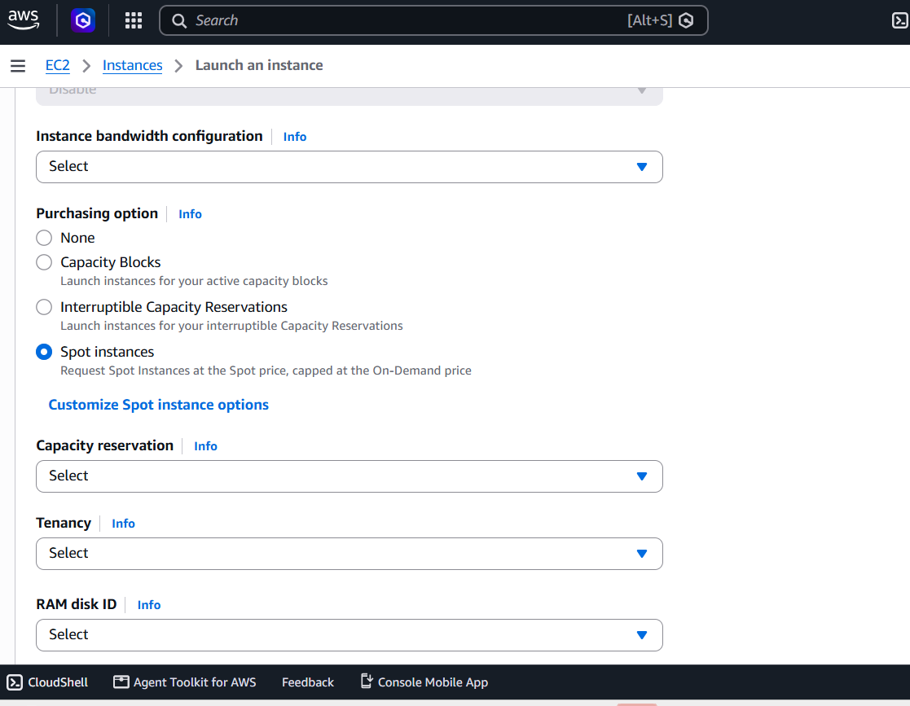
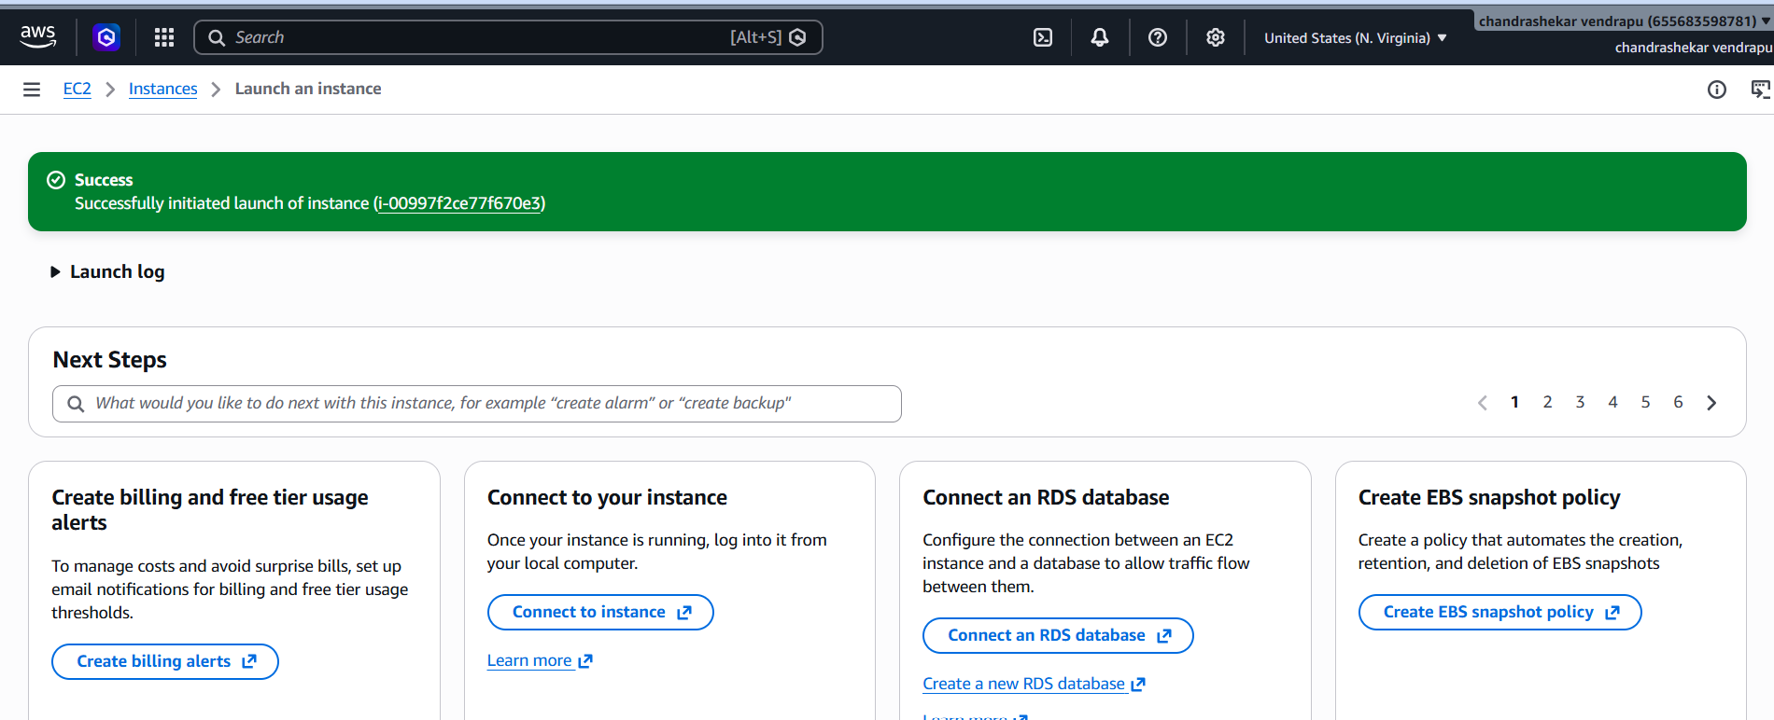
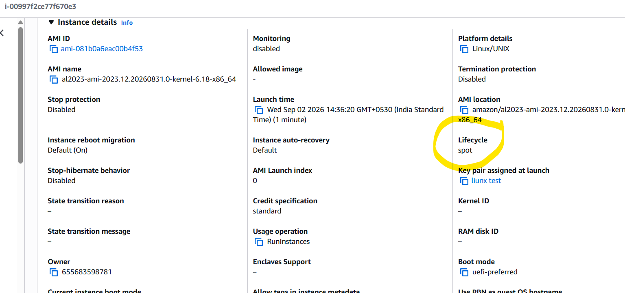
Result
Successfully launched an EC2 instance using the Spot purchasing option. The instance was
verified by checking that its lifecycle was shown as spot.

7.Enable termination policy on the EC2 created in Task 2.
Steps
1. Open AWS Management Console → EC2.
2. Go to Instances.
3. Select the Ubuntu EC2 instance created in Task 2.
4. Click Actions.
5. Select Instance settings.
6. Click Change termination protection.
7. Select Enable.
8. Click Save.
9. Verify that Termination protection is enabled for the instance.
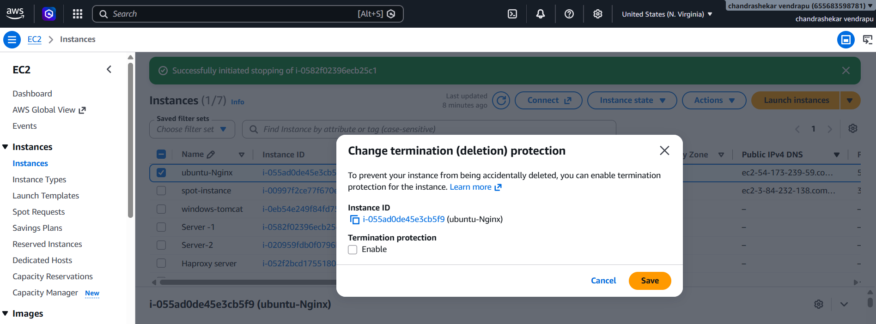
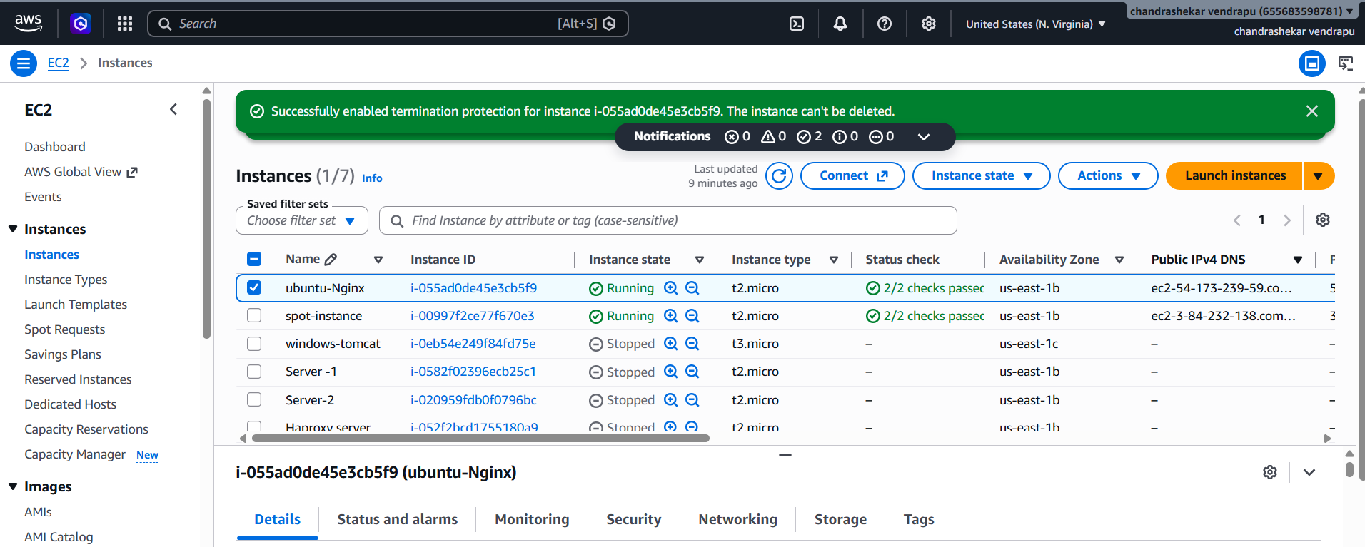
Result
Successfully enabled termination protection for the Ubuntu EC2 instance created in Task
2. This prevents the instance from being accidentally terminated.

8.Launch one EC2 using AWS CLI.
Steps
Download the file first Go to the official AWS CLI v2 download page: AWS CLI v2 Installation Guide.
Next goto aws account profile selsct security credentials
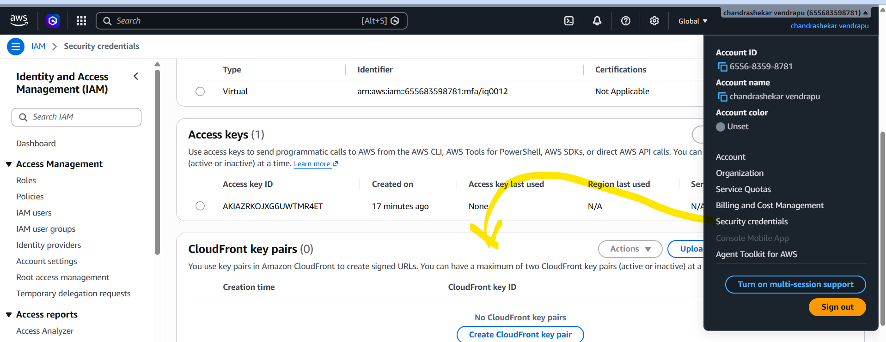
1. Open Git Bash on your Windows system.
2. Verify AWS CLI installation:aws --version
3. Configure AWS CLI:aws configureEnter your AWS credentials, region:ap-south-1and
output format:json
4. Verify AWS CLI authentication:aws sts get-caller-identity
5. Find an Amazon Linux AMI:aws ec2 describe-images \
--owners amazon \
--filters "Name=name,Values=al2023-ami-2023*" \
--query "Images | sort_by(@, &CreationDate)[-1].[ImageId,Name]" \
--output table
6. Use the AMI ID obtained from the previous command.
7. Check the available key pairs:aws ec2 describe-key-pairs --query
"KeyPairs[*].KeyName" --output table
8. Check the available security groups:aws ec2 describe-security-groups \
--query "SecurityGroups[*].[GroupId,GroupName]" \
--output table
9. Launch the EC2 instance using AWS CLI:aws ec2 run-instances \
--image-id ami-0f48d8eda3141f50a \
--instance-type t3.micro \
--key-name amazon_task \
--security-group-ids sg-03e72047d0168c893 \
--count 1
10. Verify the instance:aws ec2 describe-instances \
--query "Reservations[].Instances[].[InstanceId,State.Name,InstanceType]" \
--output table
11. Confirm that the instance state becomes:running
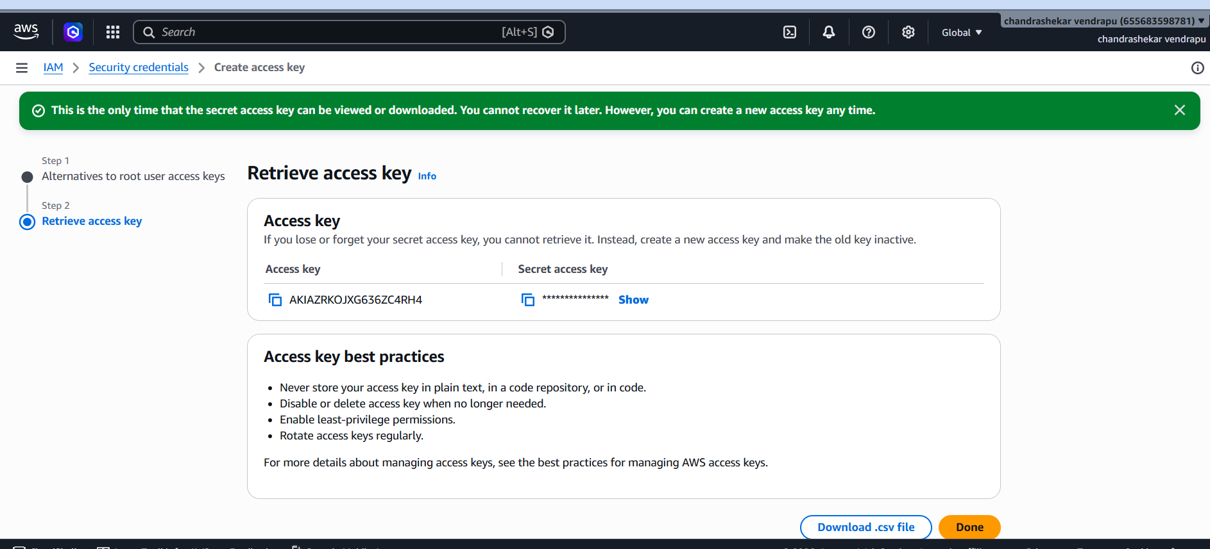

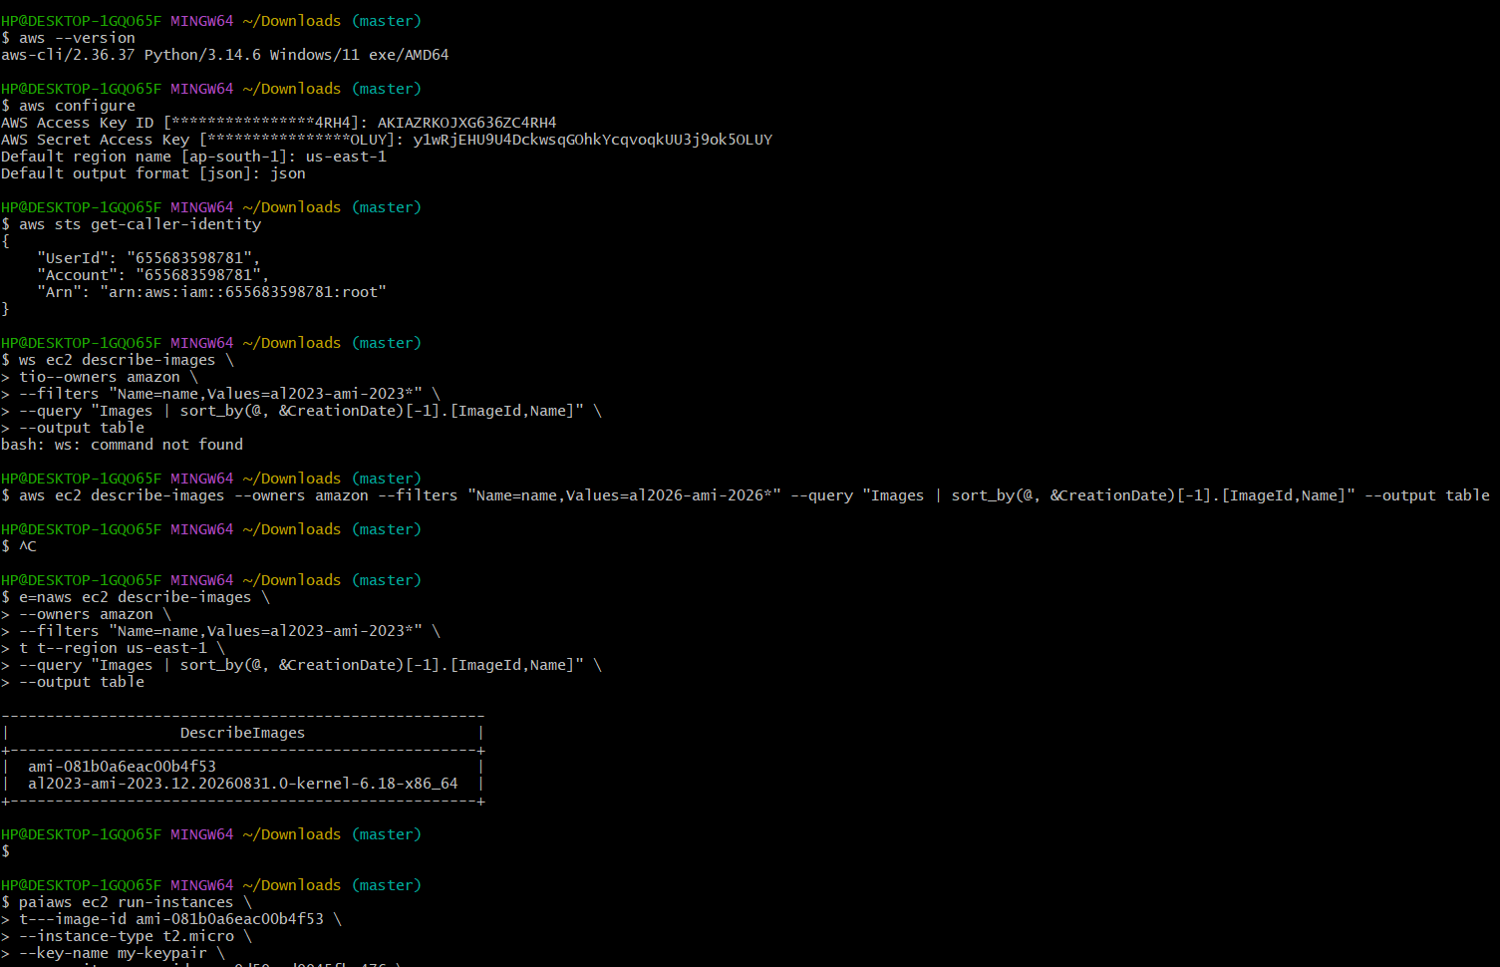

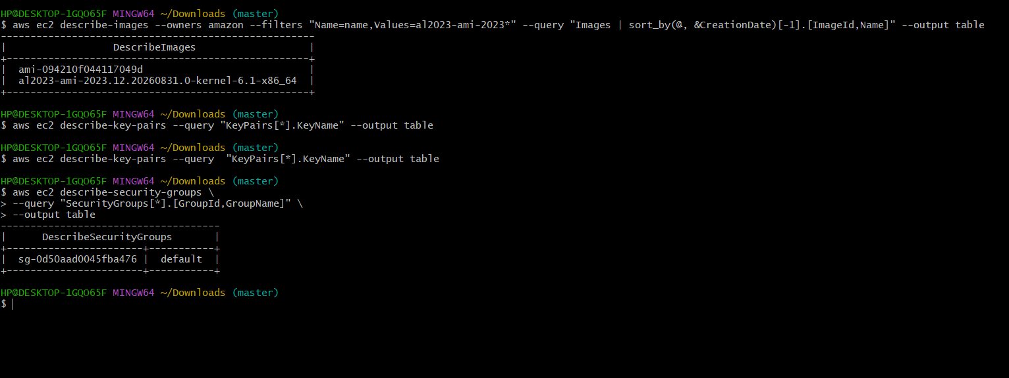
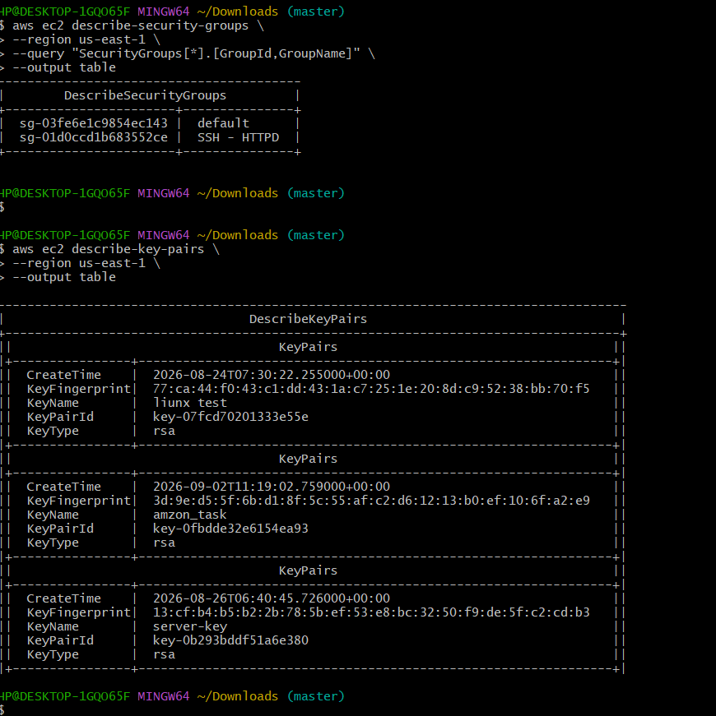
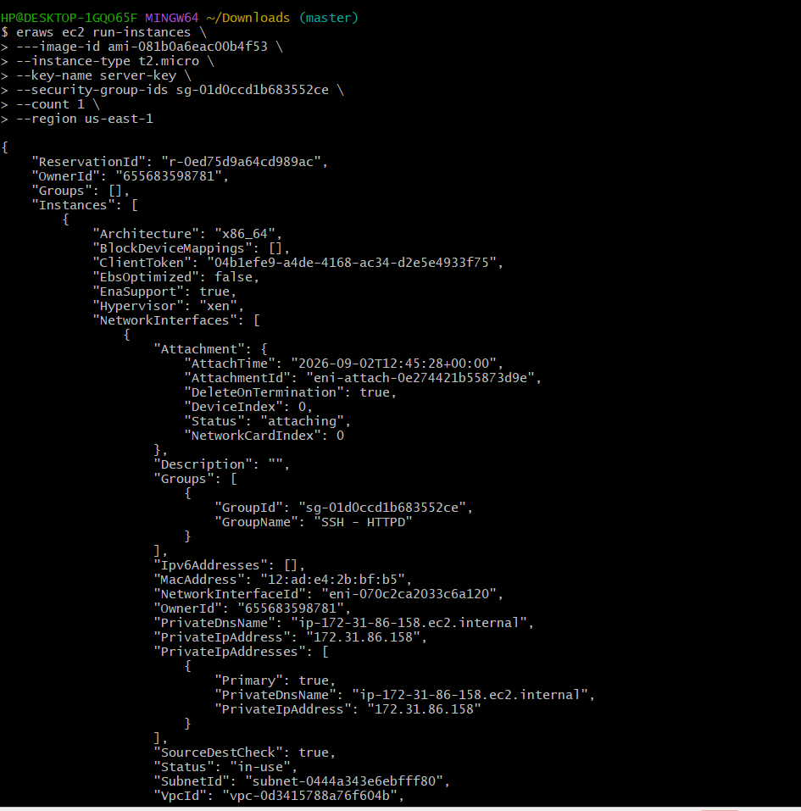
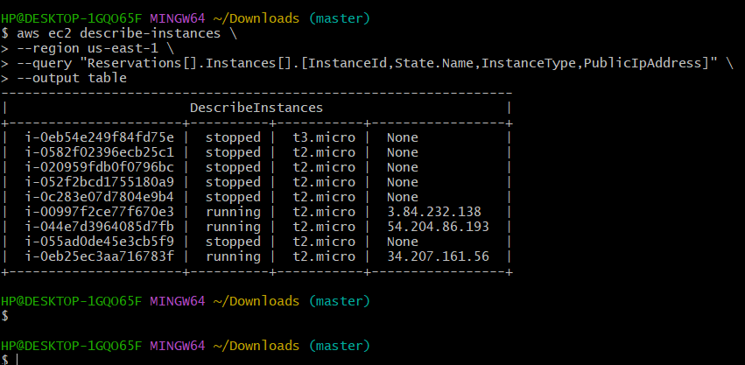

Result
Successfully launched one EC2 instance using AWS CLI. The instance was verified using
the describe-instances command and its state was confirmed as running.

